FAST FOOD BILLING AND DELIVERY SYSTEM

Project submitted to the
SRM University – AP, Andhra Pradesh
for the partial fulfilment of the requirements to award the degree of
Bachelor of Technology
In
Computer Science and Engineering
School of Engineering and Sciences
Submitted by
T HARSHIT – AP22110011476
V VIVIN JAYAKAR – AP22110011488
Y PAVAN – APP22110011474
M LALITH – AP22110011442
D BHARGAV – AP22110011465


Under the Guidance of
Prof Kavitha Rani Karnena
SRM University–AP Neerukonda, Mangalagiri, Guntur
Andhra Pradesh – 522240

CERTIFICATE
Date: 30-Apr-25
This is to certify that the work presented in this project, entitled ”FAST FOOD BILLING AND DELIVERY SYSTEM” has been carried out by Harshit, Vivin, Pavan, Lalith, Bhargav under my/our supervision. The work is genuine, original, and suitable for submission to SRM University–AP for the award of Bachelor of Technology in the School of Engineering and Sciences.

Supervisor
(Signature)
Prof Kavitha Rani Karnena

ACKNOWLEDGEMENTS
We extend our sincere gratitude to the organizations and institutions that provided the datasets and insights essential for this project. Special thanks to our mentors Prof Kavitha Rani Karnena and advisors for their invaluable guidance and constructive feedback throughout the development process.
We gratefully acknowledge the guidance and support of our faculty and mentors throughout the development of this project. We extend our sincere thanks to the developers and contributors of modern web technologies, whose innovations in Spring Boot, React.js, MongoDB, and cloud computing greatly influenced our system’s architecture. We are also thankful for the extensive documentation and tools provided by AWS S3 and Razorpay, which enabled seamless integration of cloud storage and payment functionality. The collaborative efforts and shared expertise within our team played a crucial role in building a reliable and user-friendly fast food billing and delivery application. This project stands as a testament to the power of open-source technologies and effective teamwork.

ABSTRACT
This project presents the development of a Fast Food Delivery and Billing Web Application designed to enhance user convenience in ordering meals online. The system allows customers to browse a restaurant menu, place food orders, pay online using Razorpay (test mode), and track their order status in real-time. An admin dashboard facilitates order management and tracking by the order taker. The system integrates modern technologies such as Spring Boot for backend logic, React.js for a dynamic frontend interface, MongoDB for NoSQL data handling, AWS S3 for image storage, and Razorpay for secure payments. The app provides a complete solution for online food ordering and delivery management.

Problem Statement: Fast Food Billing System
In traditional fast-food restaurants, the process of taking orders, generating bills, and managing order tracking is often manual, leading to delays, billing errors, poor customer experience, and inefficient workflow management.
There is a need for an automated system where customers can conveniently view the menu, place orders, make payments, and track their order status in real-time. Additionally, the order management process for the restaurant staff (Order Taker) should be streamlined through an Admin Panel where they can efficiently update the status of each order (such as 'Order Received', 'Order Making', and 'Order Delivered').
Therefore, a fast, reliable, and user-friendly Fast Food Billing System must be developed to automate the ordering, billing, and order tracking processes, improving both customer
Satisfaction and operational efficiency.

Introduction
The Fast Food Billing System is a modern solution designed to automate the complete process of food ordering, billing, and order tracking in a fast-food restaurant environment. Traditionally, customers place their orders manually at the counter, wait in long queues, and receive limited information about the status of their orders. This not only creates operational inefficiencies but also affects the overall customer experience.
The proposed system allows customers to browse through an online menu, select desired food items, place an order, and complete the payment digitally. Once an order is placed, a bill is automatically generated and payment is confirmed. Simultaneously, the order is forwarded to the Order Taker, who manages the kitchen operations using a dedicated Admin Panel. Through the Admin Panel, the Order Taker can update the status of the order at each stage — such as Order Received, Order Making, and Order Delivered — allowing customers to track their order progress in real time.
This system aims to streamline restaurant operations, minimize billing errors, reduce order processing time, and enhance customer satisfaction by offering transparency and efficiency in service delivery. It acts as a bridge between the customer and the kitchen operations, ensuring a smooth and organized workflow.

1 Overview:
1.1Purpose:
The purpose of this document is to define the requirements for the Fast Food Billing System. The system aims to streamline the billing process in fast food restaurants by providing an efficient, user-friendly, and error-free interface for processing customer ordering food and generating bills.

1.2 Scope:
The Fast Food Billing System is designed to:
- Process customer orders efficiently.
- Generate and print invoices.
- Support multiple payment methods.
- Provide user authentication and access control.

1.3 Definitions, Acronyms, and Abbreviations
- FFBS: Fast Food Billing System
- Admin: User with full access rights to the system
- Cashier: User responsible for handling orders and payments
- POS: Point of sale

1.4 References
- IEEE 830-1998 Standard for Software Requirements Specification
- IAN SOMMERVILLE 10th Edition Book

1.5 Overview
The purpose of this document is to outline the functional and non-functional requirements of the Fast Food Billing System. It will serve as a guide for developers, testers, and stakeholders to ensure the system meets the desired objectives.

2. Overall Description:
2.1 Product perspective
The Fast Food Billing System is designed to streamline the ordering and payment process in fast food outlets using a self-billing system. Customers can place their orders at designated self-service counters and proceed with payment based on their chosen payment method. The system aims to reduce wait times and enhance customer experience while providing vendors with a simplified order management interface.

2.2 Product Functions
->Customer Functions
- Browse Menu Items:
  - Customers can view all available food items, categorized for easy navigation (e.g., Burgers, Beverages, Snacks).
  - Product details include name, description, price, and available quantity.
- Add Items to Cart:
  - Customers can add multiple items to their cart.
  - Quantity adjustments for each item can be made before placing the order.
- Modify Cart:
  - Customers can update the cart by increasing/decreasing item quantities or removing items entirely.
- Place Order:
  - Customers can proceed to place an order after confirming the cart contents.
  - Order will be processed after admin approval.

- Order Status Tracking:
  - Customers can check the status of their order (e.g., Pending, Approved, In Progress, Completed).
->Admin Functions
- Login and Authentication:
  - Admin access is secured with authentication to prevent unauthorized entry.
- View Customer Orders:
  - Admin can view all incoming orders in real time, with details like customer name, order items, payment method, and status.
- Approve Orders:
  - Admin must manually approve the order before processing.
- Update Order Status:
  - Admin can mark orders as In Progress, Ready for Pickup, or Completed.
- Manage Products:
  - Admin can add, update, or delete food items from the system.
  - Update prices and availability as needed.
Payment Functions
- Admin approval required before confirming the order.

3 Specific Requirements:
3.1 External Interfaces
User Interface:-
- Login Screen: For user authentication.
- Order Screen: For entering and managing orders.
- Billing Screen: For generating and printing bills.
3.2 Functional Requirements
- User Authentication
  - Users must log in using a unique username and password.
  - The system should enforce role-based access control.
- Order Processing
  - Users can search and select food items from the menu.
  - The system should automatically calculate the total cost.
  - Discounts and taxes should be applied dynamically.
- Billing & Payment
  - The system should support cash, credit card, and mobile payments.
  - A receipt should be generated and printed automatically.
- Inventory Management
  - Stock levels should be updated after each transaction.
  - Alerts should be generated when stock is low.
- Reports & Analytics
  - Users can generate sales reports filtered by date.
  - Graphical representations of sales trends should be available.

3.3 Performance Requirements
- Performance: The system should handle 100 transactions per hour(in minimum).
- Usability: The UI should be intuitive and easy to navigate.
- Security: Data should be encrypted and protected against unauthorized access.
- Maintainability: System updates should not disrupt operations.

3.4 Logical Database Requirement
->Database Management System (DBMS): The system should support relational databases like MySQL or MongoDB.
->Data Storage Capacity: The database should efficiently handle at least 10,000 records (orders, inventory, and transactions).
3.5 Design Constraints
->Platform Dependency
- The system must be compatible with Windows and Linux-based POS systems.
- It should support touchscreen-based interfaces for ease of use.
->Security Constraints
- Passwords must be stored using encryption .
- Only authorized users should have access to certain features (role-based access control).

3.6 Software System Quality Attributes
->Performance
- The system should process 100 transactions per hour without noticeable delays.
- Order processing and bill generation should complete within 2 seconds.
->Usability
- The system should have an intuitive and user-friendly interface.
- Should support touchscreen input for fast processing.
- Provide multilingual support for diverse users.
->Security
- User data should be encrypted using SHA-256 for passwords and TLS for transactions.
- Implement role-based access control to restrict functionalities based on user type.
->Maintainability
- The system should be designed using modular architecture to facilitate updates.
- Code should follow proper documentation and structured coding practices.
->Scalability
- Should support future expansions, handling multiple outlets and increased transactions.
- Database should handle 10,000+ records without performance degradation.
->Availability
- The system should work 24/7 without requiring frequent restarts.
- Data should be backed up daily to ensure recovery in case of failures.

3.6 Object Oriented Models
1. Class Diagram (Key Objects & Relationships)
- User (Abstract class)
  - Attributes: userID, username, password, role(Customer or Admin)
  - Methods: login(), logout(), changePassword()
  - Subclasses: Admin, Cashier, InventoryManager
- Order
  - Attributes: orderID, items[], totalAmount, timestamp, paymentStatus
  - Methods: calculateTotal(), applyDiscount(), confirmOrder()
- MenuItem
  - Attributes: itemID, name, price, category, availability
  - Methods: updatePrice(), checkAvailability()
- Inventory
  - Attributes: itemID, stockLevel, supplier, lastRestocked
  - Methods: updateStock(), notifyLowStock()
- Transaction
  - Attributes: transactionID, orderID, paymentMethod, status
  - Methods: processPayment(), generateReceipt()
- Report
  - Attributes: reportID, dateRange, salesData, generatedBy
  - Methods: generateSalesReport(), exportReport()
- Testing a small module (like just the Cart page) is much easier and faster than testing the full application at once.
- If bugs arise, it’s easier to isolate and fix them because changes are smaller and localized to one module.

4. Flexibility for Enhancements
- Suppose after developing the cart module, developer realize that he want to add a "promo code" feature.
- In the incremental model, we can easily insert new modules or features without disturbing the already completed parts.
5. Risk Management
- In a big project like a food delivery app, risks (like payment integration failure, cloud storage issues, etc.) are real.
- By developing incrementally, we detect problems earlier (for example, if Razorpay integration is hard, you find that out before the app is fully built).

Layer |  |  |  |  |  |  | Technology
Frontend |  |  |  |  |  |  | React.js, Bootstrap
Backend |  |  |  |  |  |  | Spring Boot (Java)
Database |  |  |  |  |  |  | MongoDB
Authentication |  |  |  |  |  |  | Spring Security
Cloud Storage |  |  |  |  |  |  | AWS S3
Payment |  |  |  |  |  |  | Razorpay (test mode)
Tools |  |  |  |  |  |  | Postman, Git, VS Code

USER PANEL HAS:
- Food categories
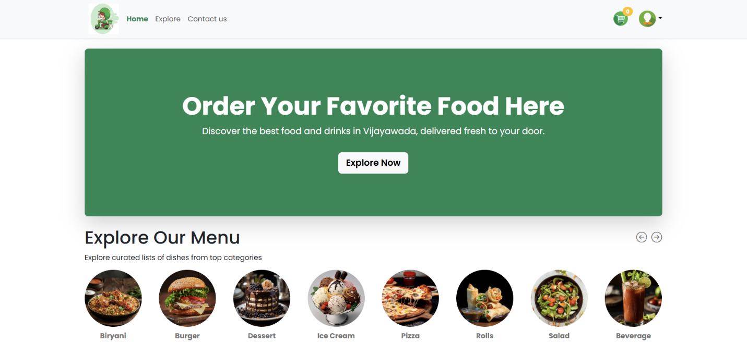

- List Of Food
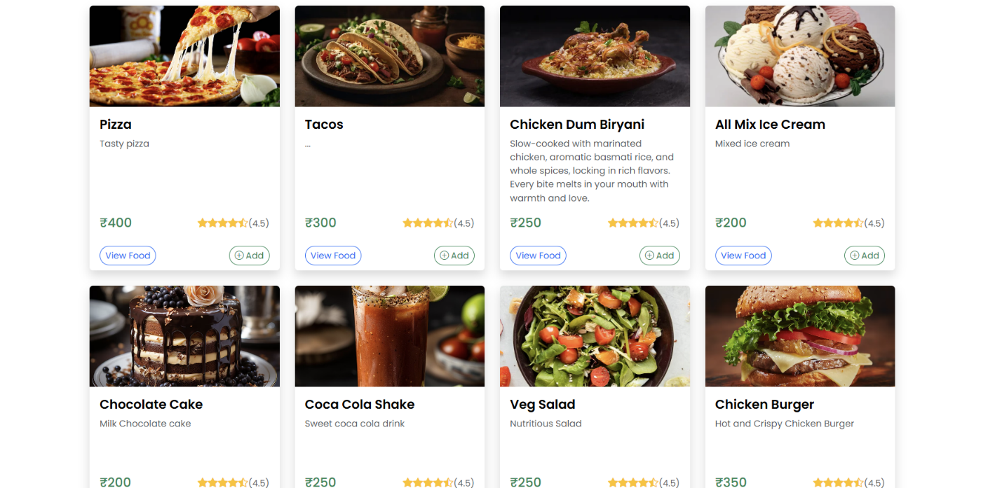

- Search For Food
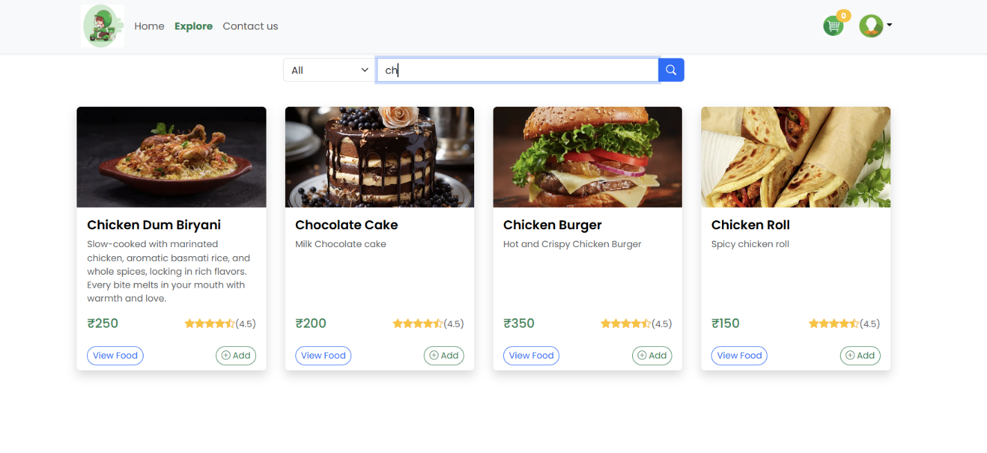

- Shopping Cart
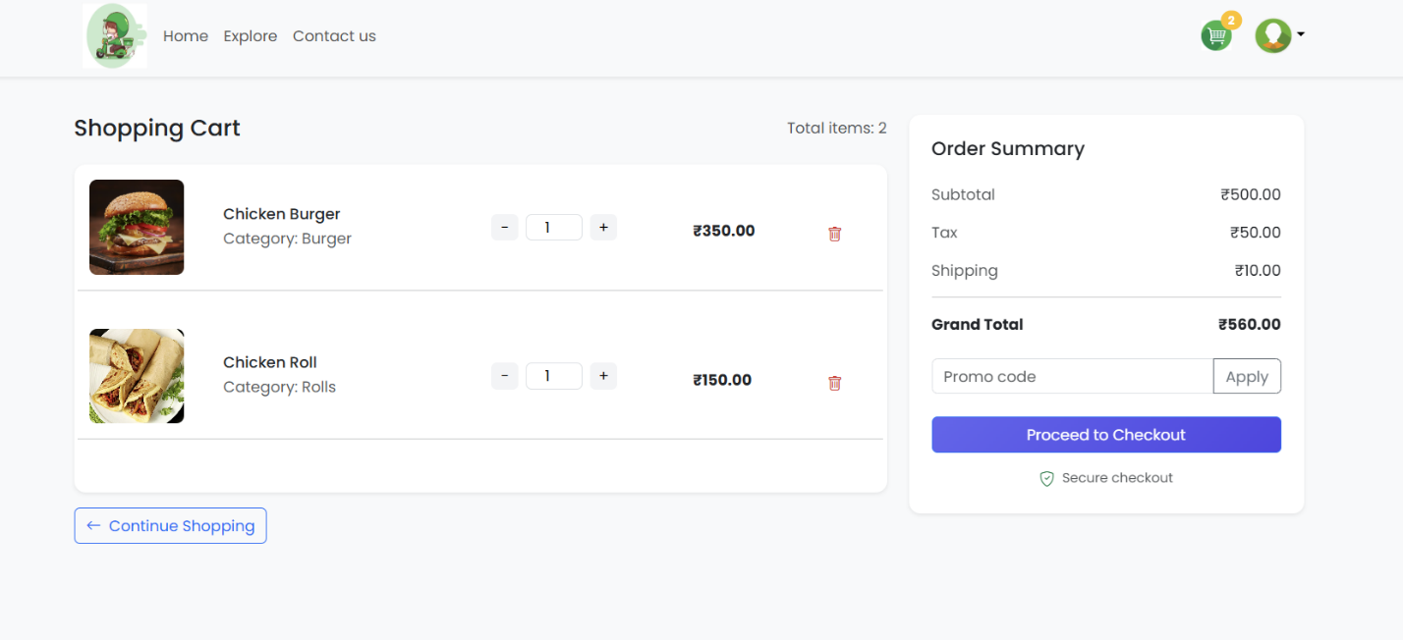
- Billing Address
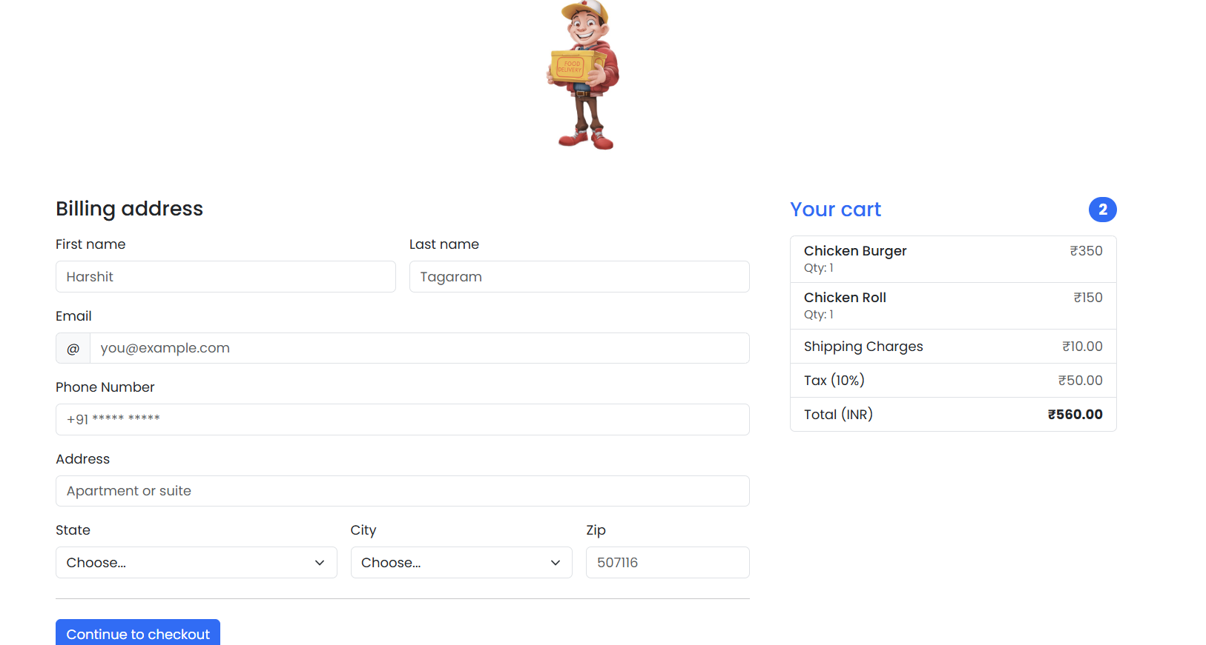

ADMIN PANEL HAS:
- Add Food
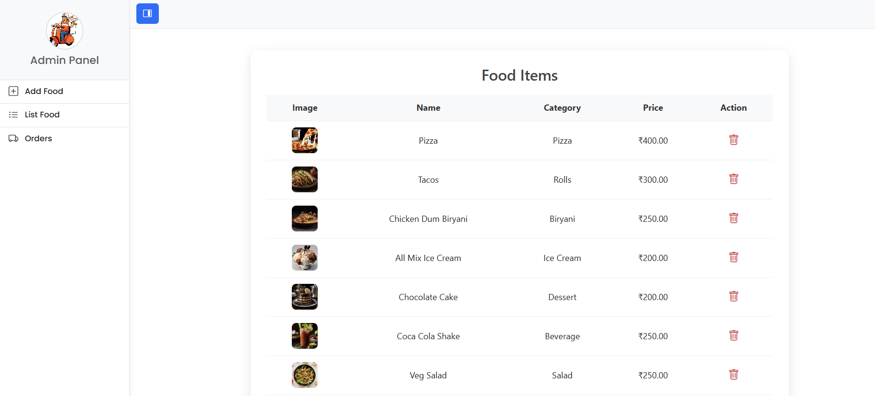

- List Food
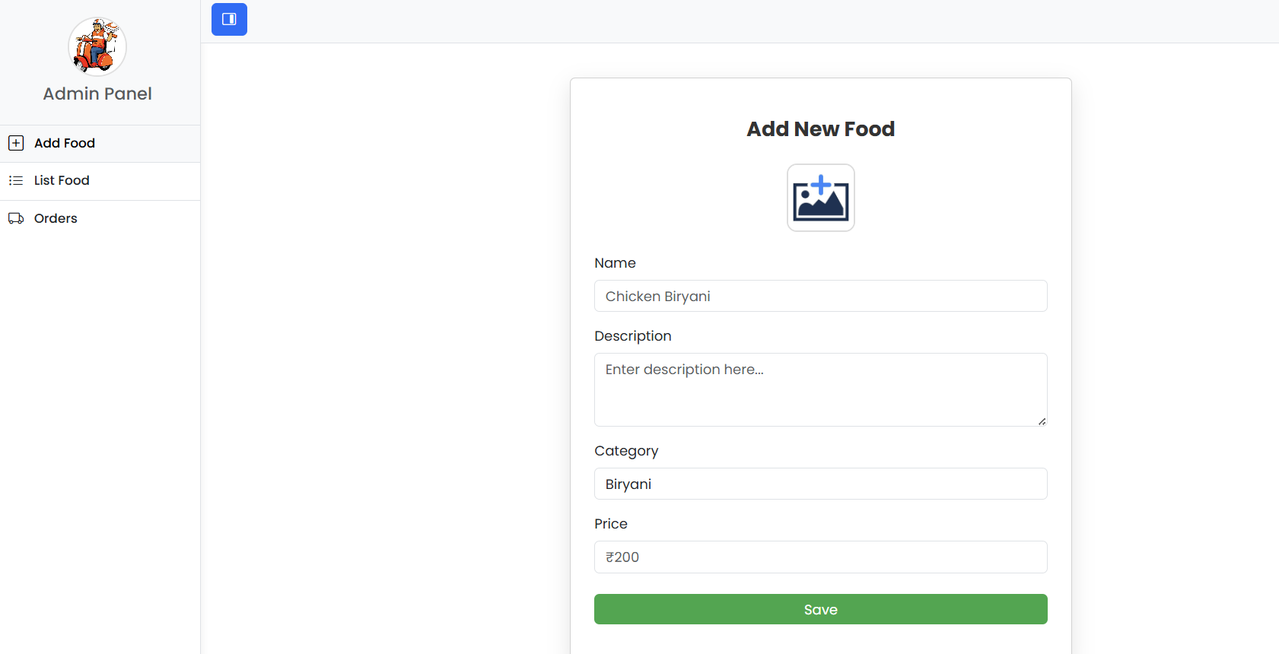
- Orders
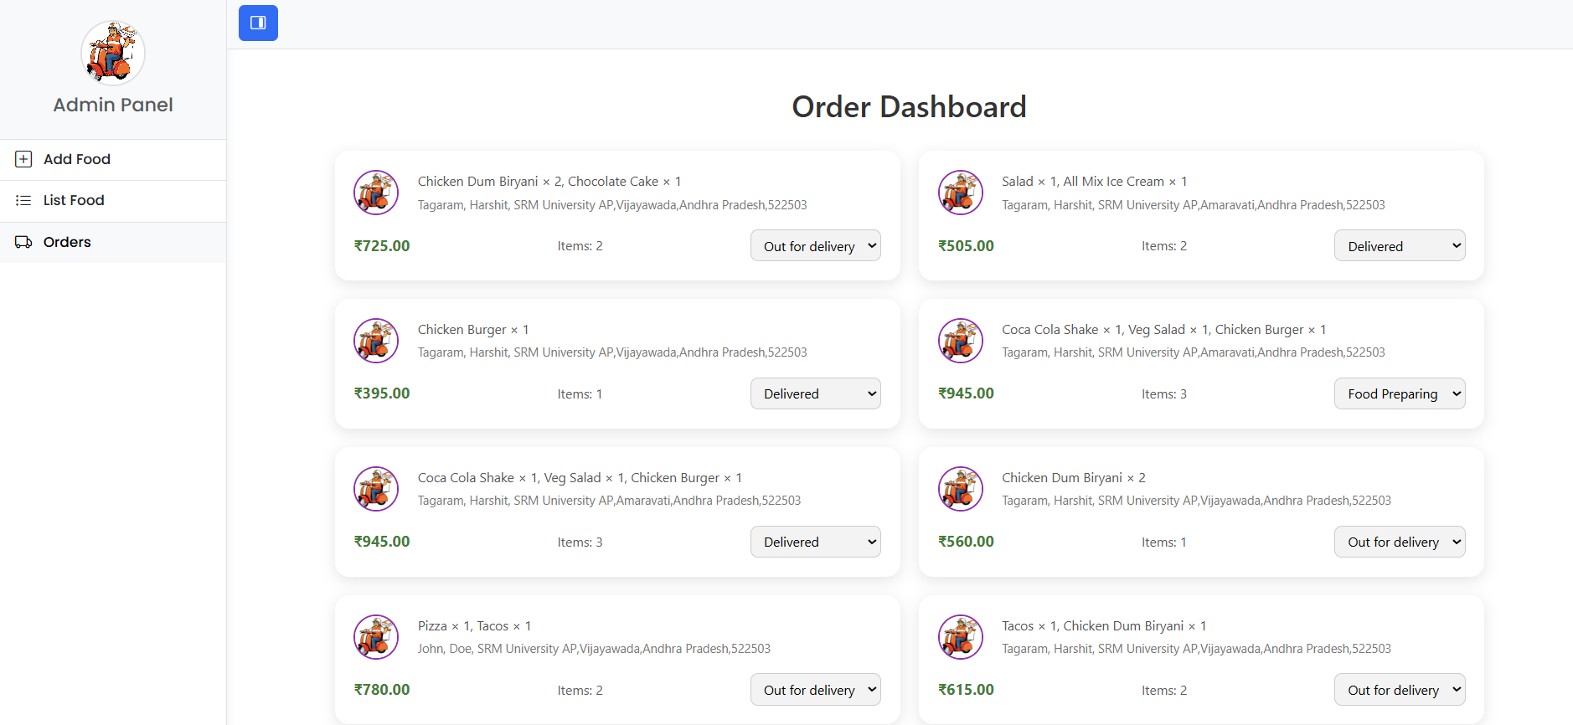

Future Enhancements
- Integration with live delivery tracking (Google Maps API).
- Real-time notifications (SMS/Email) for status updates.
- Add role-based access for kitchen and delivery staff.
- Multiple restaurant support.
- Review and rating system.

Conclusion
The Fast Food Billing and Delivery Web Application streamlines the entire process of ordering food, from selection to delivery. By integrating cloud storage, secure payments, and real-time tracking, the app meets the needs of users and admins efficiently. It serves as a model for building scalable, modern web applications in the food service domain.

